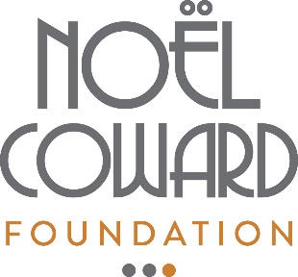
Noël Coward Foundation
Application cover sheet

Please fill in the information below as fully as possible. This form should accompany your full application and all relevant support materials.

ABOUT YOUR ORGANISATION:
Name of applying organisation:
Contact name and position:
Email address:
Street address:
Aims and activities of your organisation:
Are you a Registered Charity? |  | If yes, please supply your Charity Registration Number:
Have you previously applied to the NCF? |  | If yes, the date of your most recent NCF award:

ABOUT YOUR PROPOSED PROJECT:
Name of project:
Brief overview, including any specific areas for which you are requesting funding:
What is the anticipated outcome of the project?
How will the project be evaluated?

Amount requested: |  | Date funds required:

