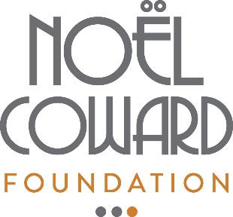
Noël Coward Foundation
Application cover sheet – Summer 2020

Please fill in the information below as fully as possible. This form should accompany your full application which should be no more than two side of A4 or letter-size paper.
ABOUT YOUR ORGANISATION:
Name of applying organisation:
Contact name and position:
Email address:
Street address:
Are you a Registered Charity? |  | If yes, please supply your Charity Registration:
Date of most recent NCF award:

ABOUT YOUR FUNDING REQUEST / PROPOSED PROJECT:
Name of project (if applicable) or area(s) of your organisation’s activity for which you need funding at this time:
How has your organisation been affected by the Covid-19 pandemic?
Please outline your plan to monitor how any NCF grant is spent. NOTE: the NCF will still require a report on any Covid-19-related funding.

Amount requested:

